**Jenkins Shared Library Demo 16-07-2023**

**Step 1: Create a Github Repository in that create a folder and name it as vars (default name for a shared library).**

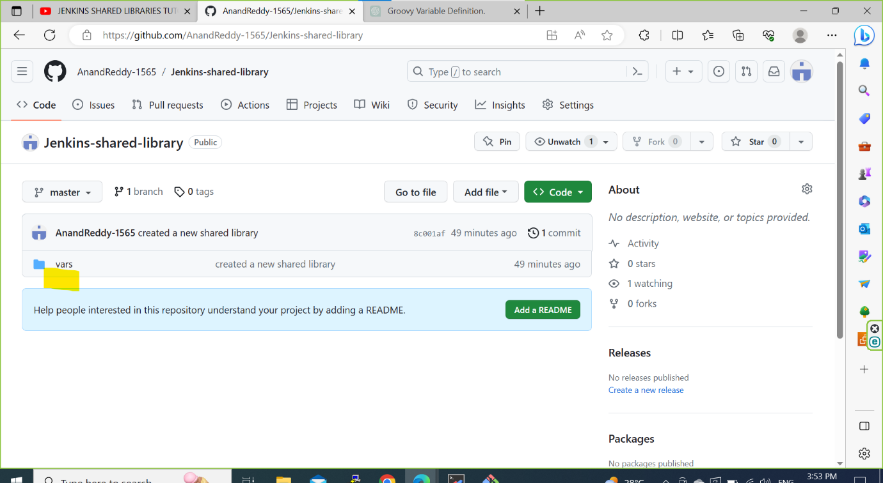

**Step 2: Create a file for a shared library and name it as hellowWorld(use camel case format).**

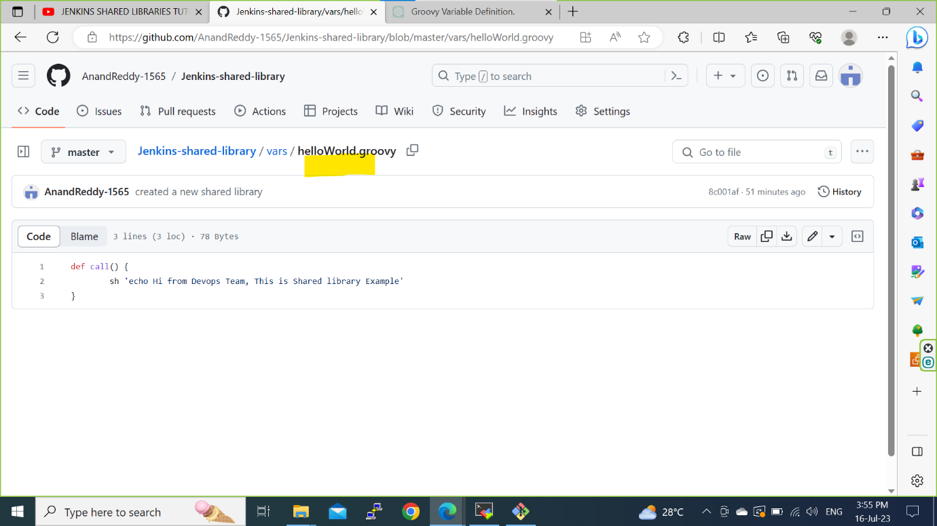

**Step 3: Open a Jenkins and click on ‘Manage Jenkins’ and navigate to ‘Global Pipeline Libraries’ and give name as my-shared-library** 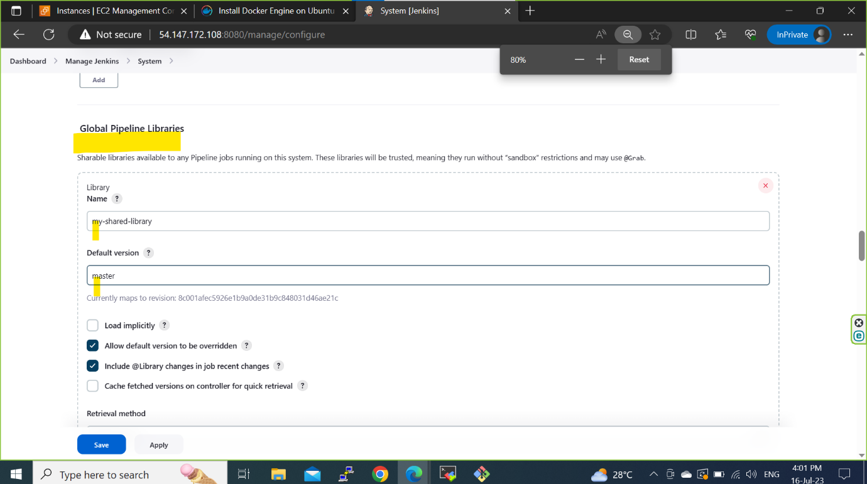

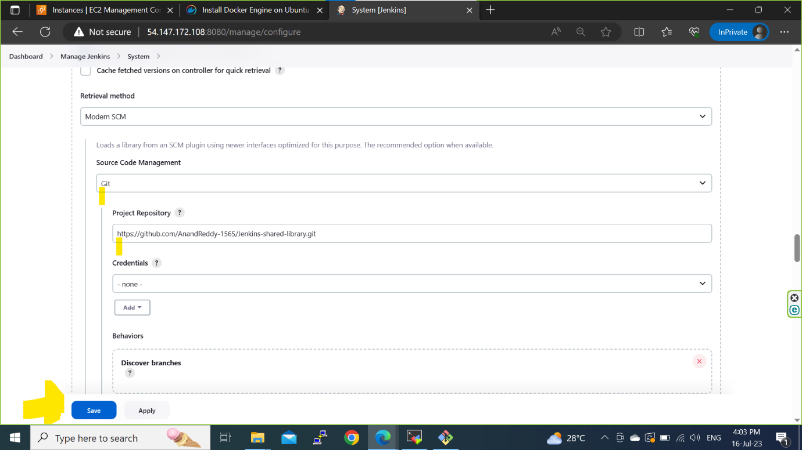

**Step 4: In Jenkins Create a Pipeline job name it as Test-pipeline.**

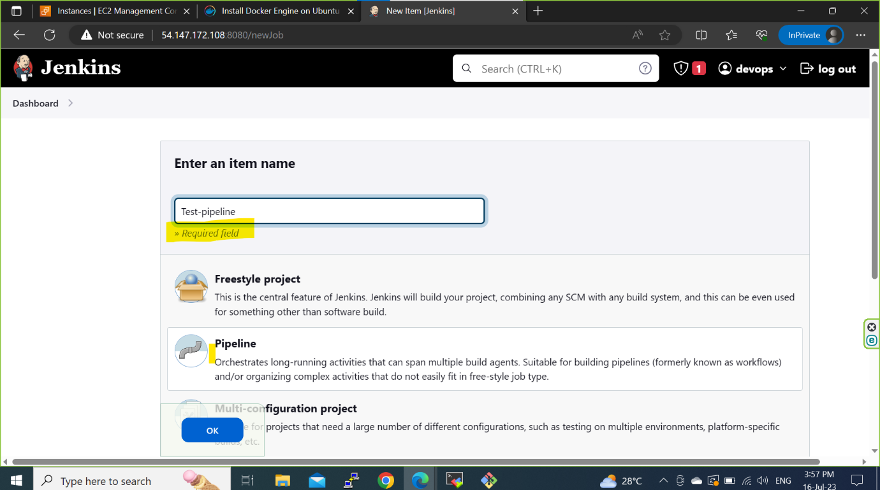

**Step 5: Write a syntax and use ‘@Library _’ for using a Shared library and we write a file name of the shared library to call that particular library and save.**

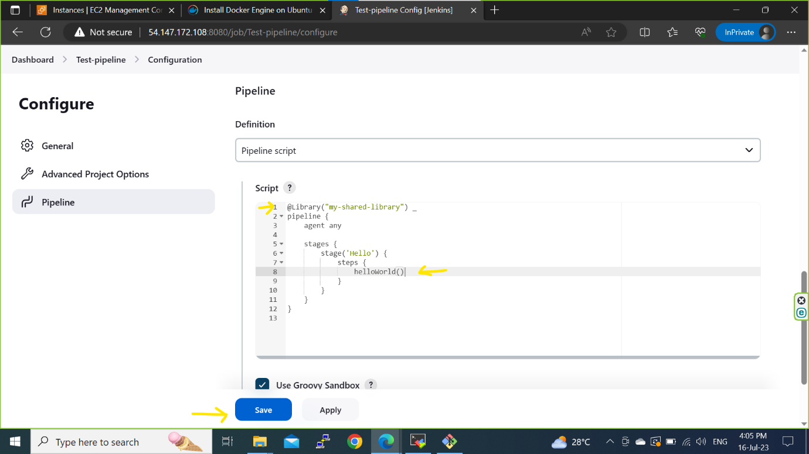

**Step 6: Build the pipeline**

